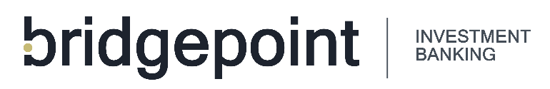

2023-2024 BRIDGEPOINT FELLOWS APPLICATION

OVERVIEW
The Bridgepoint Fellows mission is to provide high school students the opportunity to learn about career opportunities within finance / investment banking. Bridgepoint strives to help students complete this program and eventually go on to have successful careers and give back to their communities. This program will provide the Fellow monthly mentorship meetings, quarterly office visits (shadowing), project opportunities, networking / relationship building and technical skills development. The applicant must be in the Omaha, NE metro area, have a high achieving academic background, be a proven community steward and show interest in career development within the finance / investment banking industry.

APPLICANT INFORMATION
Full Name: |  |  |  |  | Date:
 | Last | First |  | M.I.

Address:
 | Street Address | Apartment/Unit #

 | City | State | ZIP Code

Phone: |  | Email:

EDUCATION
High School: |  | Address:

Grade Level: |  | GPA:
Volunteer Hours Completed (Last Twelve Months):

REFERENCES
Please list two references
Full Name: |  | Relationship:
Company: |  | Phone:
Address:
Email:
Full Name: |  | Relationship:
Company: |  | Phone:
Address:
Email:

PERSONAL Statement
Bridgepoint Fellows aims to educate high school students about the world of investment banking. In less than 1,000 words, please complete a personal statement that helps us understand your story. Tell us about your background, volunteer efforts in the last 12-24 months, why you’re interested in becoming a Bridgepoint Fellow and why you should be chosen for this opportunity. As a purpose driven investment bank, we are excited to learn more about you, your interest in investment banking and how we as a firm can help you achieve those goals.

I certify that my answers are true and complete to the best of my knowledge.

Signature: |  | Date:

TIMELINE / SUBMISSION DETAILS
Application Due Date: Friday, September 29, 2023
If sending your application via mail, please send to:
Bridgepoint Investment Banking
1299 Farnam St., Suite 1550
Omaha, NE 68102

Program Start Date: Monday, October 23, 2023

Program End Date: Friday, June 14, 2024

Submission Process: Email applications to Andrew Nussbaum, anussbaum@bridgepointib.com

